Commodore PET/CBM80xx/40xx Diagnostic Clip Rev. 3
Module Description
Table Of Contents
1. Introduction 2
2. Test procedure 3
2.1. Brief discription 3
2.2. Notes 4
3. Diagnostic Software 5
3.1. 80 col CRTC 5
3.2. 40 col CRTC 6
3.3. 40 col non-CRTC 7
4. Complete Diagnostic Clip Set 8
5. Connectors and Jumpers 10
5.1. J1 – Connector to test clip/6502 Ribbon Cable Adapter 10
5.2. Jumpers & Switches 10
5.2.1. SW1 Reset Switch 10
5.2.2. JP6/SW3 – AB13 & AB14 10
5.2.3. SW2 – The DIP Switch 11
5.2.4. SW4 – Active/Remove Switch 11
6. Resources 11
6.1. Websites 11
6.2. Commodore Training: 40xx/80xx Service Manual 12
6.2.1. DIAGNOSTIC BOX DESCRIPTION 12
6.2.2. Test description 13
7. Annotations 14
7.1. 3D printed Case 14
7.2. Ribbon Cable 15
8. Revision History 16
8.1. Rev. 0 16
8.2. Rev. 1 16
8.3. Rev. 2 16
8.4. Rev. 3 17

Introduction
The diagnostic clip is a diagnostic tool, which is originally issued by Commodore. It contains the diagnostic software, which has to fit to the board type, that is tested. For testing, it is connected to the 6502, switches off the ROMs on the mainboard and/or redirects the Kernal accesses to its built in EPROM.
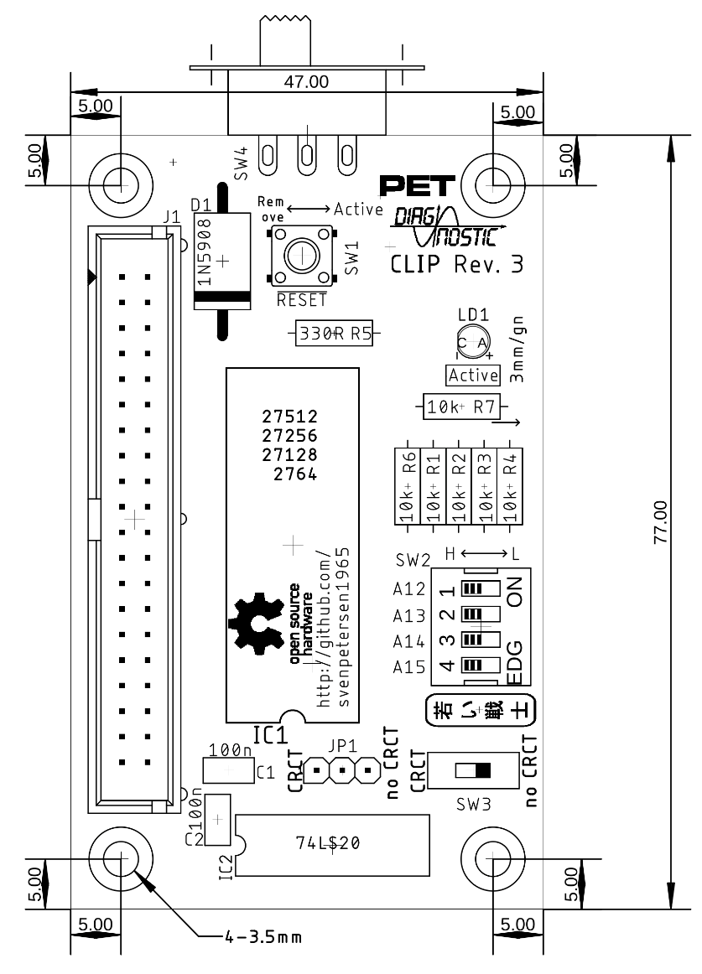
Figure 1: Dimension of the PCB
The original hardware consists of:
- DIP40 test clip (3M is still producing this kind of clip – They are available from Mouser and Digikey: https://www.digikey.com/en/products/detail/3m/923743-40/12075, which is $94.07 in February 2023)
- the box with the EPROM/Test software)
- the keyboard feedback dongle
- user port feedback dongle
There is an extra box for each version of the software.
The goal of this development is to eliminate the need for an expensive DIP40 test clip and to merge the different box designs to one PCB. Further, shorting A13 and A14 to GND should be prevented.
The result is a 4 PCB solution:
- the clip box with a ribbon cable
- a ribbon cable adapter for the 6502
- a keyboard feed back
- a user port feed back
The EPROM in the clip box is fully connected to the 6502 µprocessor address and data bus. When connected (and configured properly), the test software is run after powering up the machine. The two main types of mainboards require different methods of making the test software appear in the system.
- CRTC machines, like the 8032, have a signal, which can switch off all ROMs on the mainboard (except the character set) and the test software resides at $Fxxx instead of the Kernal. It comes with its own RESET vector @ $FFFC/D (it points to $F000, the start of the test software)
- Non CRTC machines, like the PET2001 or CBM30xx: the Kernal access is redirected to the option ROM address space $9xxx. This happens by (brutally) shorting the address signals A13 and A14 to GND – $F/1111_{BIN} becomes a $9/1001_{BIN}. The test software starts at $9800, the redirected reset vector is now at $9FFC/D and it points to $9800
Note: CRTC means “Cathode Ray Tube Controller. The first PETs had a video circuit, solely consisting of TTL ICs and the Character ROM. This includes the first “dynamic PETs”, like the CBM 30xx. The later machines had a controller chip (6545) as the heart of the video circuit. It can be configured for 40 column and 80 column machines and is a bit more flexible. The CBM 80xx and most CBM 40xx are CRTC machines.
For testing the CBM8296, it is required to switch the /NOROM signal off while the Active ↔ Remove switch is in the Remove state, since it is also controlled by software. This is realize in Rev. 3.

Test procedure

Brief discription
The diagnostic hardware (clip/ribbon cable adapter, clip box, keyboard and user port dongles have to be connected before power up.
After power up, the diagnostic software is started. It consists or the first basic tests, which make sure, that the basic system is working:
- Printing the character set on the screen
- Testing the “TV RAM” (screen memory)
- Testing the Zero Page
- Testing the stack
- Copying the actual test software into the RAM, starting at $0200. Jumping to that software
- Waiting for the clip to be removed
NOTE: A switch installed on JP5 allows to switch off , which is logically removing the clip EPROM from the system. As a non-CRTC machine the CBM3016 was tested.
The copied test software first waits for the clip to be removed by checking the (redirected) reset vector. If it does not point to $F000 or $9800 for a couple of seconds, it is assumed, that the clip is removed. Then testing is proceeded:
- Video Test
- Checksum Test (CRTC machines)
- Horizontal (video) Test
- Video RAM Test (CRTC machines)
- 32k RAM test
- ROM Test (shows checksum only)
- Refresh Test (dynamic RAM refresh)
- Keyboard Test
- 60Hz (non CRTC) or 50Hz (CRTC) IRQ (interrupt) test
- Timer 1 Test
- Timer 2 Test
- Cassette 1 Test
- Cassette 2 Test
- IEEE DIO Test
- IEEE Ctrl Test
This part of the test is cycling until the Reset switch is pressed or the computer is power down. The tests are described in chapter 6.2.2

Notes
The user port is used to monitor the video signals, SRQ and EOI from the IEEE Bus, the Tape write and read signals and the “Diagsens” and “Graphic” signal.
I would not consider this as a proper user port test.
The IEEE signals are fed back internally, there is no external feedback, so the driver chips are not tested.
The tape port TPWRITE signal on the user port us fed back to both TPREAD1 and TPREAD2. CASS SWITCH #1 and #2 are not tested, neither is CASS MOTOR #1 and #2.
The testing will stop on the first failed test.

Diagnostic Software

80 col CRTC
The file name in the “Diagnostic Software” folder is “80_col_diagnostic_v1.1.bin”. It is suitable for 80 col 80xx and 40xx machines (with the 12” monitor).
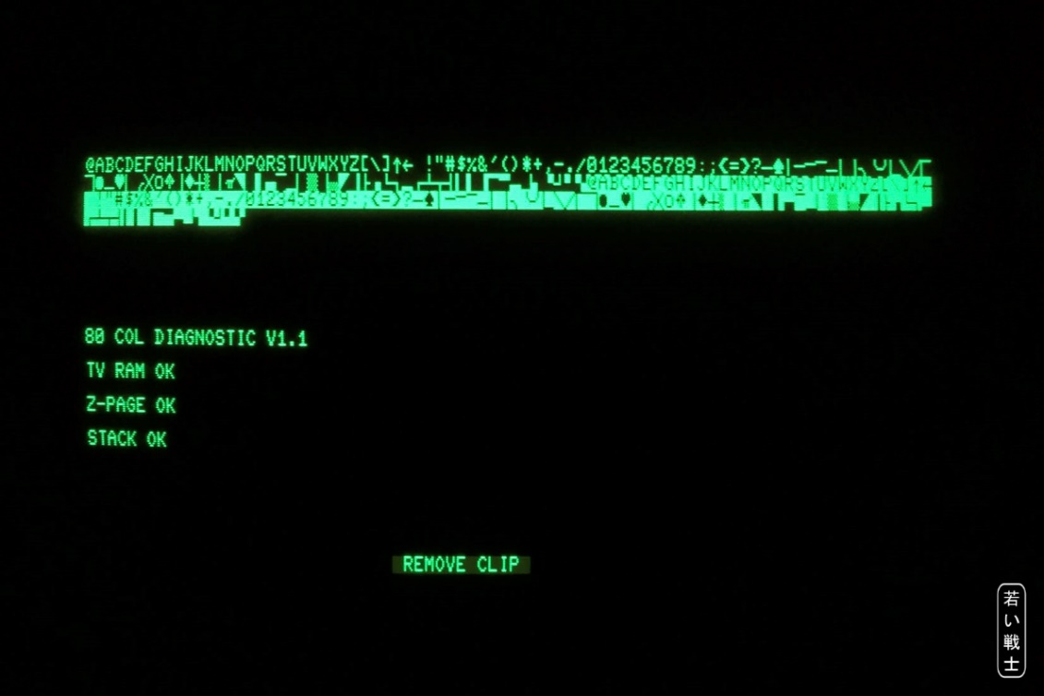
Figure 1: 80_col_diagnostic_v1.1.bin - first page
After removing the clip, respectively switching it to “remove”, the test continues on the 2nd page.
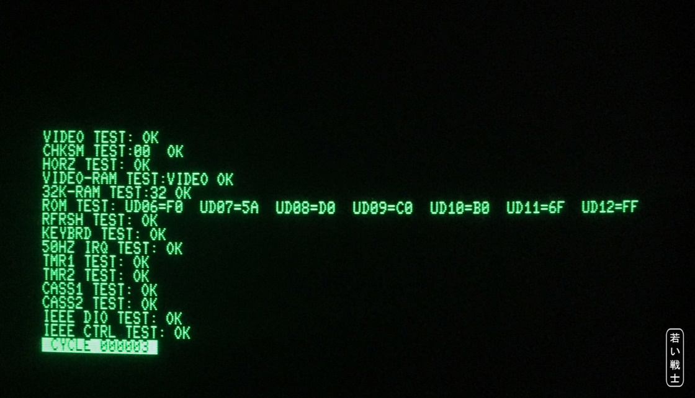
Figure 2: 80_col_diagnostic_v1.1.bin - second page

40 col CRTC
Since no such a computer is available, just the opening page can be shown on a 40 col. screen. A further test on a non CRTC machine (CBM3016) fails. The test itself passes on the CBM8032, but the output screen is not properly aligned.
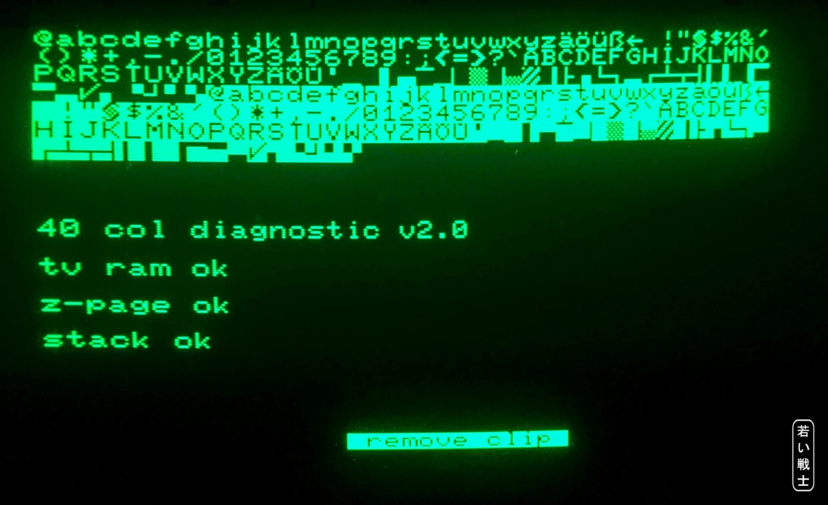
Figure 3: 40_col_diagnostic_v2.0.bin - first page
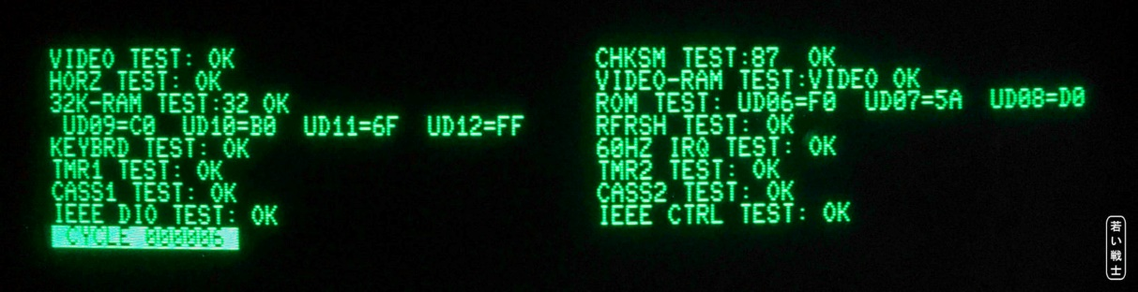
Figure 4: 40_col_diagnostic_v2.0.bin - second page (on an 80 col machine)

40 col non-CRTC
This test should work with all 40 column non-CRTC machines. The 2nd page is scrolling, so an upper and lower half of the looping test is shown.
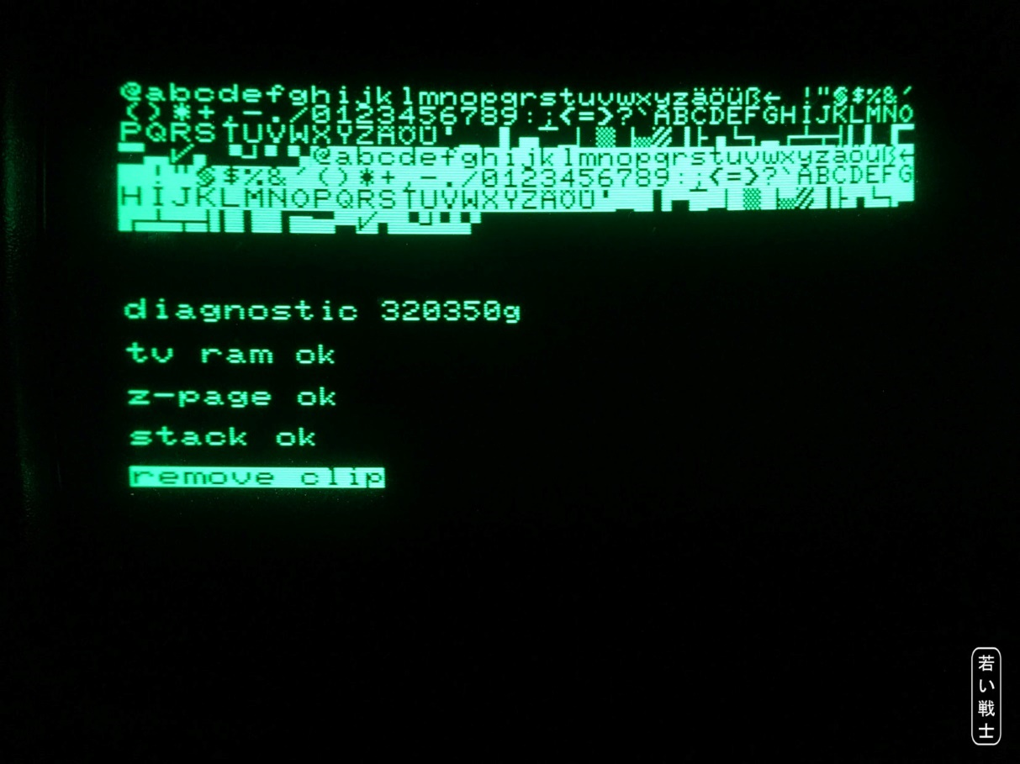
Figure 5: 901447-30_diagnostic_320350g_$9000.bin - first page
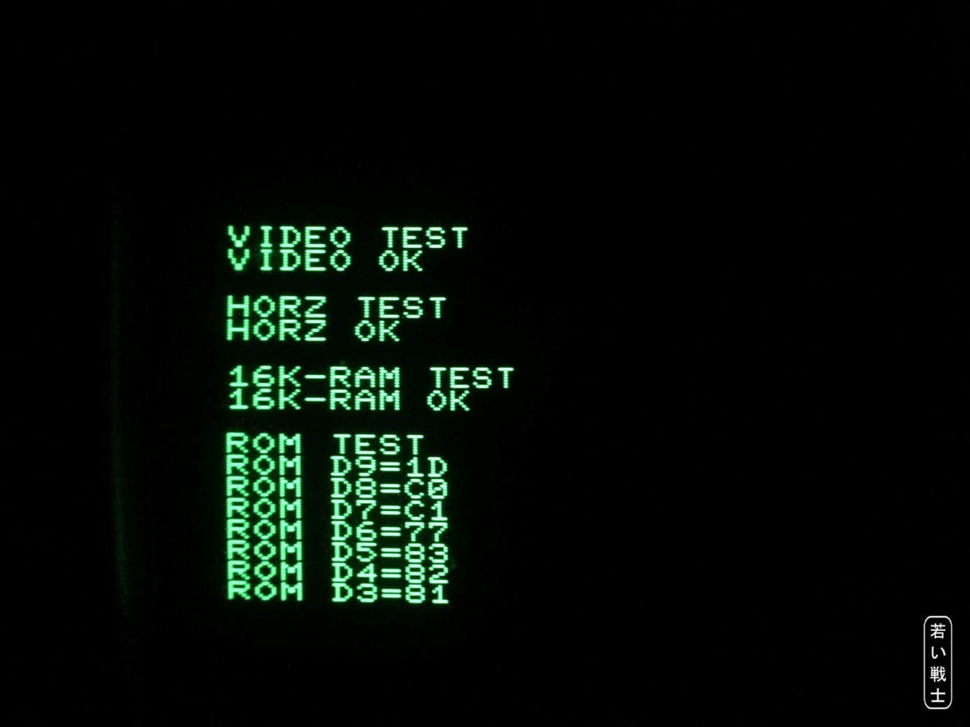
Figure 6: 901447-30_diagnostic_320350g_$9000.bin - 2nd page (upper half)
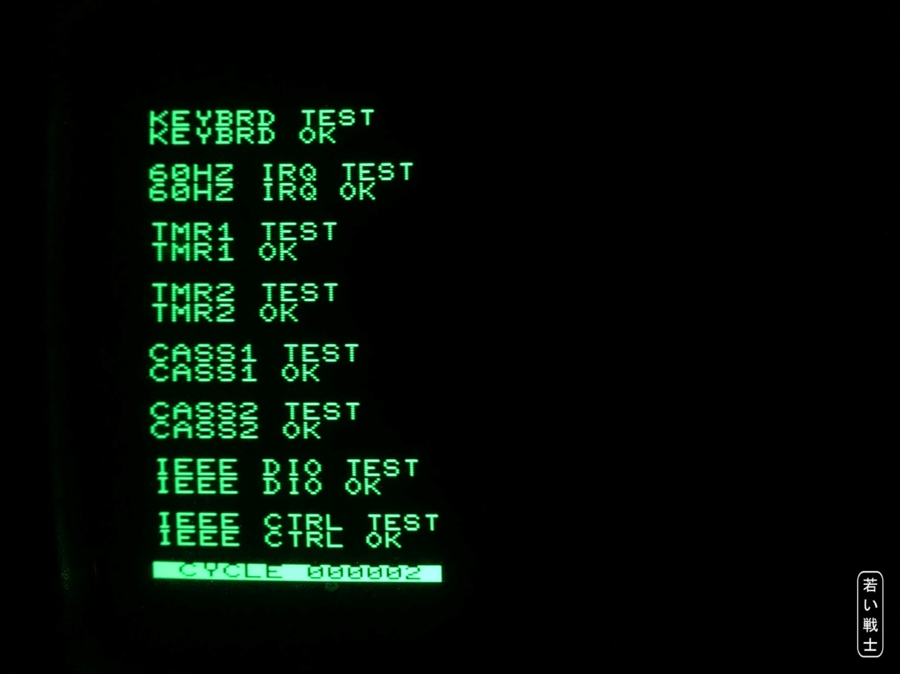
Figure 7: 901447-30_diagnostic_320350g_$9000.bin - 2nd page (lower half)

Complete Diagnostic Clip Set
In Figure 8 all required PCBs are shown, including the short 40 pin ribbon cable.
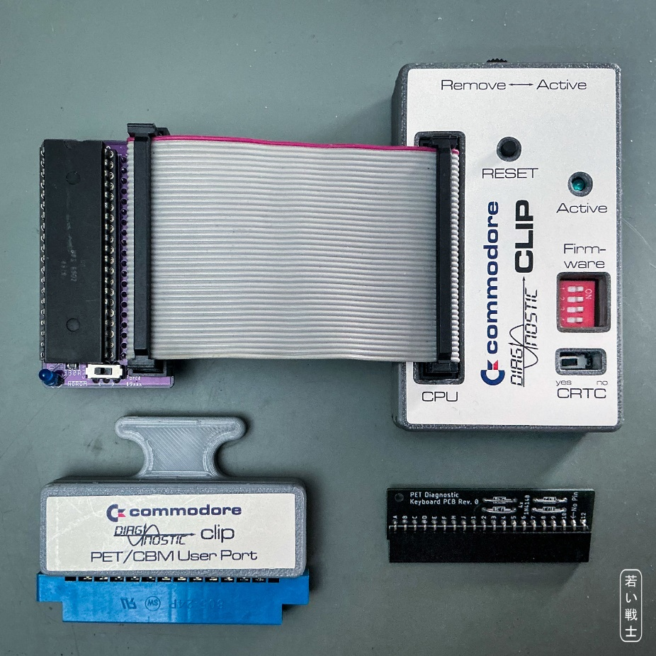
Figure 8: Diagnostic set, 6502 inserted in Ribbon cable adapter
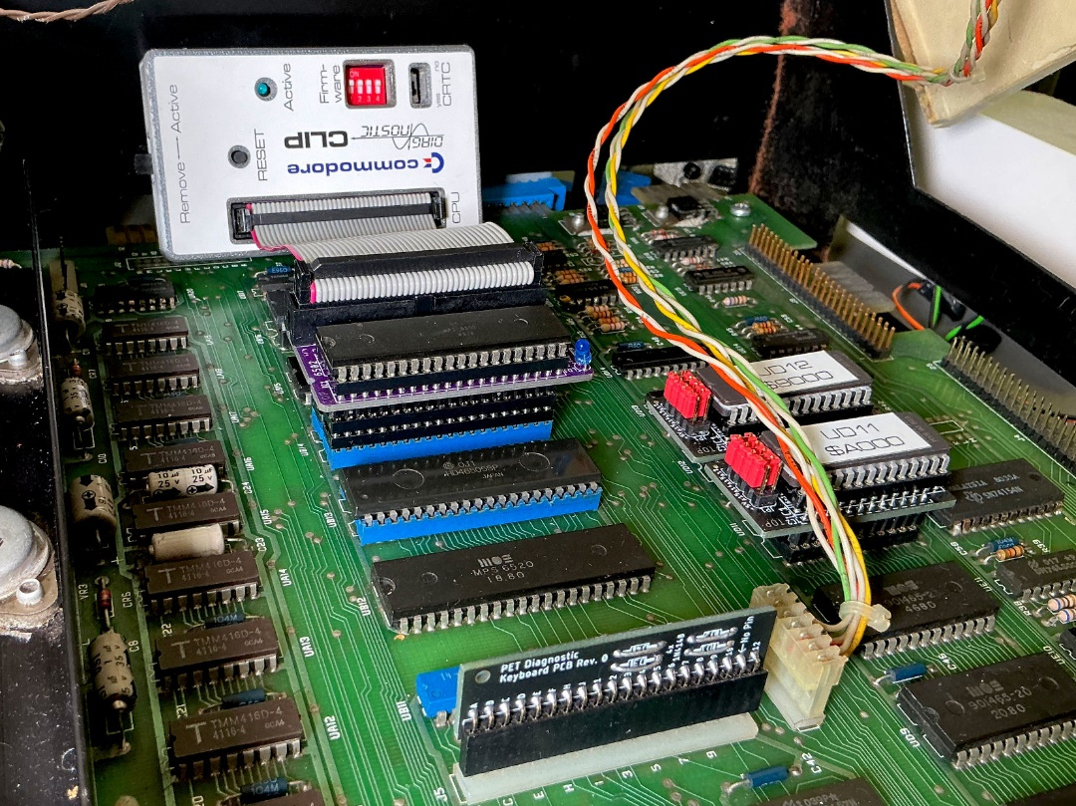
Figure 9: Diagnostic clip connected to the 6502 ribbon cable adapter (in the CBM8032)

Connectors and Jumpers

J1 – Connector to test clip/6502 Ribbon Cable Adapter
A 2x20 box connector, 2.54mm pitch
Signal | Pin | Pin | Signal
GND (6502, Pin 1) | 1 | 2
RDY | 3 | 4 | PHI2
PHI | 5 | 6 | S.O.
 | 7 | 8 | PHI0
 | 9 | 10 | n.c. (6502, Pin 36)
 | 11 | 12 | n.c. (6502, Pin 35)
SYNC | 13 | 14 | R/
5V | 15 | 16 | DB0
AB0 | 17 | 18 | DB1
AB1 | 19 | 20 | DB2
AB2 | 21 | 22 | DB3
AB3 | 23 | 24 | DB4
AB4 | 25 | 26 | DB5
AB5 | 27 | 28 | DB6
AB6 | 29 | 30 | DB7
AB7 | 31 | 32 | AB15
AB8 | 33 | 34 | AB14
AB9 | 35 | 36 | AB13
AB10 | 37 | 38 | AB12
AB11 | 39 | 40 | GND (6502, Pin 21)

Jumpers & Switches

SW1 Reset Switch
The Reset switch serves for resetting the tested computer.

JP6/SW3 – AB13 & AB14
This selects the CRTC/non CRTC mode
Signal | Pin | Pin | Signal
n.c. | 1 | 2 | AS14
AB13 | 3 | 4 | AB14
GND | 5 | 6 | GND

CRTC machines, like the 80xx or most 40xx: Jumper 1 – 3 & 2 – 4.
Non-CRTC machines, like the PET20xx or CBM 30xx: Jumper 3 – 5 & 4 – 6.
Internally the mini slide Switch SW3 can be installed instead of JP6, which is the recommended solution.

SW2 – The DIP Switch
The DIP-Switch serves for selecting the test software (one of 16 possible) from the EPROM (27C512) that can be run on the clip. The size of the test software is 4kByte, while the size of the EPROM is 64kByte. If it is desired to have a smaller EPROM, the highest (not required) address bits have to be HIGH and the DIP-switch can be smaller.
EPROM | SW | Address Bits | DIP-Switch
27C256 | 8x4k | A15 open/HIGH | position 1-3
27C128 | 4x4k | A15&A14 open/HIGH | position 1-2
27C64 | 2x4k | A15&A14&A13 open/HIGH | position 1
The OFF position of a switch means HIGH, the ON Position means LOW.
4 | 3 | 2 | 1 | A15..12 | 4k Slot | EPROM Offset
on | on | on | on | 0000 | 0 | $0000
on | on | on | off | 0001 | 1 | $1000
on | on | off | on | 0010 | 2 | $2000
on | on | off | off | 0011 | 3 | $3000
on | off | on | on | 0100 | 4 | $4000
on | off | on | off | 0101 | 5 | $5000
on | off | off | on | 0110 | 6 | $6000
on | off | off | off | 0111 | 7 | $7000
off | on | on | on | 1000 | 8 | $8000
off | on | on | off | 1001 | 9 | $9000
off | on | off | on | 1010 | 10 | $A000
off | on | off | off | 1011 | 11 | $B000
off | off | on | on | 1100 | 12 | $C000
off | off | on | off | 1101 | 13 | $D000
off | off | off | on | 1110 | 14 | $E000
off | off | off | off | 1111 | 15 | $F000

SW4 – Active/Remove Switch
This switch is initially set to “Active”, after the computer is started (by power on or reset), the diagnostics software runs the first page/part of the diagnostic test routine (Figure 1 and Figure 3). In this state, the internal signal is pulled LOW and is connected to the (external) signal that is connected to the CPU socket pin 5 and the rest of the computer.
To continue the diagnostic test, the switch SW4 has to be set to the “Remove” position. In this position, the signal is HIGH (via pull-up R7) and it is also disconnected from the external signal.
The separation of the internal and the external signal has no effect with the PETs or CBM40xx and 80xx, but obviously the CBM8296 can modify the signal via a register to access the RAM, which is in the same address space of the ROMs. Since there is no real clip in this project, which is physically disconnected from the computer, the signal has to be separated with SW4 to prevent the clip from interfering with the test.

Resources

Websites
The information for creating this project, like the schematics of the original diagnostic clips and some test software was retrieved from André Fachat’s website:
- http://www.6502.org/users/andre/petindex/diag/index.html
Further test software and the connections of the keyboard and user port feedback was retrieved from Bo Zimmerman’s website:
- http://www.zimmers.net/anonftp/pub/cbm/firmware/computers/pet/other/index.html
- http://www.zimmers.net/anonftp/pub/cbm/schematics/computers/pet/diagnostics.txt

Commodore Training: 40xx/80xx Service Manual
Some further descriptions can be found in the (German) "Commodore Training_40xx_80xx_Service Manual" on Carsten's great retro-commodore.eu website .
Page 33ff:

DIAGNOSTIC BOX DESCRIPTION
"DIAGNOSTIC-BOX BESCHREIBUNG
Die Diagnostic-Box ist ein Testgerät, mit dem die wichtigsten Komponenten auf der Logic-Platine der Zentraleinheiten getestet und ein hoher Prozentsatz der Fehler gefunden werden kann.
Die Tastatur selbst und das Video-Board wird nicht überprüft. Für jede Zentraleinheit gibt es eine spezielle Diagnostic-Box.
Anschluß und Starten des Testprogramms:
Zur Diagnostic-Box gehören zwei Diagnostic-Stecker, einer für den User-Port und einer für die Tastatur. An der Box befindet sich ein 40-poliges Flachbandkabel mit einem IC-Clip.
Dieser Clip wird auf den Prozessor gesteckt und die beiden Diagnostic-Stecker kommen an die entsprechenden Positionen
Wenn die rote LED leuchtet, kann das Diagnose-Programm durch drücken der roten Taste (Reset) gestartet werden.
Auf dem Bildschirm wird nun angezeigt welcher Test gerade läuft, ob er fehlerfrei durchläuft, oder was für Fehler erkannt wurden. Wird ein Fehler erkannt, stoppt das Testprogramm. Treten keine Fehler auf, werden die Tests laufend wiederholt."
Translated to English:
"DIAGNOSTIC BOX DESCRIPTION
The Diagnostic-Box is a test device with which the most important components on the logic board of the central units are tested and a high percentage of errors can be found.
The keyboard itself and the video board are not checked. There is a special diagnostic box for each computer.
Connection and start of the test program:
The Diagnostic Box includes two diagnostic plugs, one for the User port and one for the keyboard. There is a 40-pin ribbon cable with an IC clip attached to the box.
This clip is put on the processor and the two diagnostic plugs are connected to the appropriate positions/connectors.
When the red LED lights up, the diagnostic program can be started by pressing the red button (Reset). The screen now shows which test is currently running and whether it is passed or failed, or what kind of errors were detected. If an error is detected, the test program stops. if there are no fails, the tests are repeated continuously."
[...]

Test description
"Testbeschreibung
Nach Betätigung der Reset-Taste wird der CRT-Controller initialisiert und der CBM-Zeichensatz in den oberen Teil des Bildschirms geschrieben womit festgestellt wird ob es überhaupt möglich ist Daten auf den Bildschirm zu schreiben.
Nun wird Zero-Page und Stack getestet. Treten hier Fehler auf wird entweder ein RAM als defekt angezeigt oder eine Adressleitung.
Eine genaue Erkennung des Fehlers ist aber in manchen Fällen nicht möglich, sodaß zum Teil unrichtige Fehlermeldungen ausgegeben werden. Um den Fehler zu lokalisieren kann man die CAS-Leitungen an den RAMs vertauschen und den Test neu starten. Wird wieder eine Fehlermeldung ausgegeben, so liegt der Fehler wahrscheinlich nicht an den RAM', sondern an der Ansteuerung (Adressleitungen, Refresh, RAS, CAS, RAM R/W, MUX A).
Ist Zero-Page und Stack in Ordnung wird ein Testprogramm in den RAM-Bereich geschrieben und die Aufforderung REMOVE CLIP erscheint auf dem Bildschirm.
Wird nun die Diagnostic-Box vom Prozessor entfernt, werden von dem in der Zero-Page befindlichen Testprogramm die weiteren Teile des Systems getestet. Die ausgegebenen Fehlermeldungen sind im Allgemeinen zuverlässig."
English:
"Test description
After pressing the reset button, the CRT controller is initialized and the CBM character set is displayed on the upper part of the screen, which determines whether it is even possible to write data on the screen.
Now the zero-page and stack are tested. If errors occur here, either a RAM is displayed as defective or an address line
In some cases, however, an exact detection of the error is not possible, so that in some cases incorrect error messages are output. To localize the error, you can swap the CAS lines on the RAM's and restart the test. If an error message is output again, the error is probably not due to the RAM, but to the control (address lines, refresh, RAS, CAS, RAM R/W, MUX A).
If the zero page and stack are OK, a test program is written to the RAM area and the REMOVE CLIP request appears the screen.
If the diagnostic box is now removed from the processor, the other parts of the system are tested by the test program in the zero page. The error messages issued are generally reliable."
CHKSM TEST: | Um zu überprüfen, ob das Testprogramm richtig in die Zero-Page geladen wurde, wird eine Prüfsumme gebildet die 00 ergeben muß.
VIDEO RAM TEST: | Es werden in jede Bildschirmadresse Daten geschrieben wieder gelesen und verglichen
32K RAM TEST: | Es wird der gesamte RAM-Speicher außer Zero-Page und Stack getestet
ROM TEST: | Es werden Prüfsummen von jedem ROM gebildet (siehe Liste der Prüfsummen)
RFRSH TEST: | Es werden Daten in die RAMs geschrieben, eine Zeit lang gewartet und die Daten wieder ausgelesen. So wird überprüft, ob der Refresh in Ordnung ist.
KEYBOARD TEST: | Es wird die Funktion des Decoders und des PIA überprüft
50 HZ IRQ TEST: | Es wird getestet, ob von dem Signal Vert Drive über den PIA Interrupts erzeugt werden.
TMR1/2 TEST: | Es werden die beiden TIMER des VIA getestet
CASS1/2 TEST: | Es werden die beiden Cassetten-Ports getestet Beim Lesen werden Interrupts erzeugt (VIA, PIA)
IEEE Tests: | Es werden Daten und Steuersignale getestet. Die IEEE-Buffer werden mitgetestet

English:
CHKSM TEST: | In order to check whether the test program has been loaded correctly into the zero page, a checksum is formed which must result 00.
VIDEO RAM TEST: | Data is written to each screen address, read back and compared
32K RAM TEST: | The entire RAM memory except for the zero page and stack is tested
ROM TEST: | Checksums are generated from each ROM (see list of checksums)
RFRSH TEST: | Data is written to the RAMs, waited for a while and the data is read out again. This checks whether the refresh is OK
KEYBOARD TEST: | The function of the decoder and the PIA is checked
50 HZ IRQ TEST: | It is tested whether interrupts are generated by the signal Vert Drive via the PIA
TMR1 / 2 TEST: | The two TIMERS of the VIA are tested
CASS1 / 2 TEST: | The two cassette ports are tested When reading, interrupts are generated (VIA, PIA)
IEEE Tests: | Data and control signals are tested. The IEEE buffers are also tested

Annotations

3D printed Case
The case of Rev. 0 is not suitable for any later version of the PCB than Rev.0. The PCBs rev. 1 and 2 require the case revision 1. PCB Rev. 3 requires a Case Rev. 3
For the switch, two M2x5 screws are required. For the case, four C2.9 x 9.5 (DIN7981) self-tapping plastic screws are recommended.
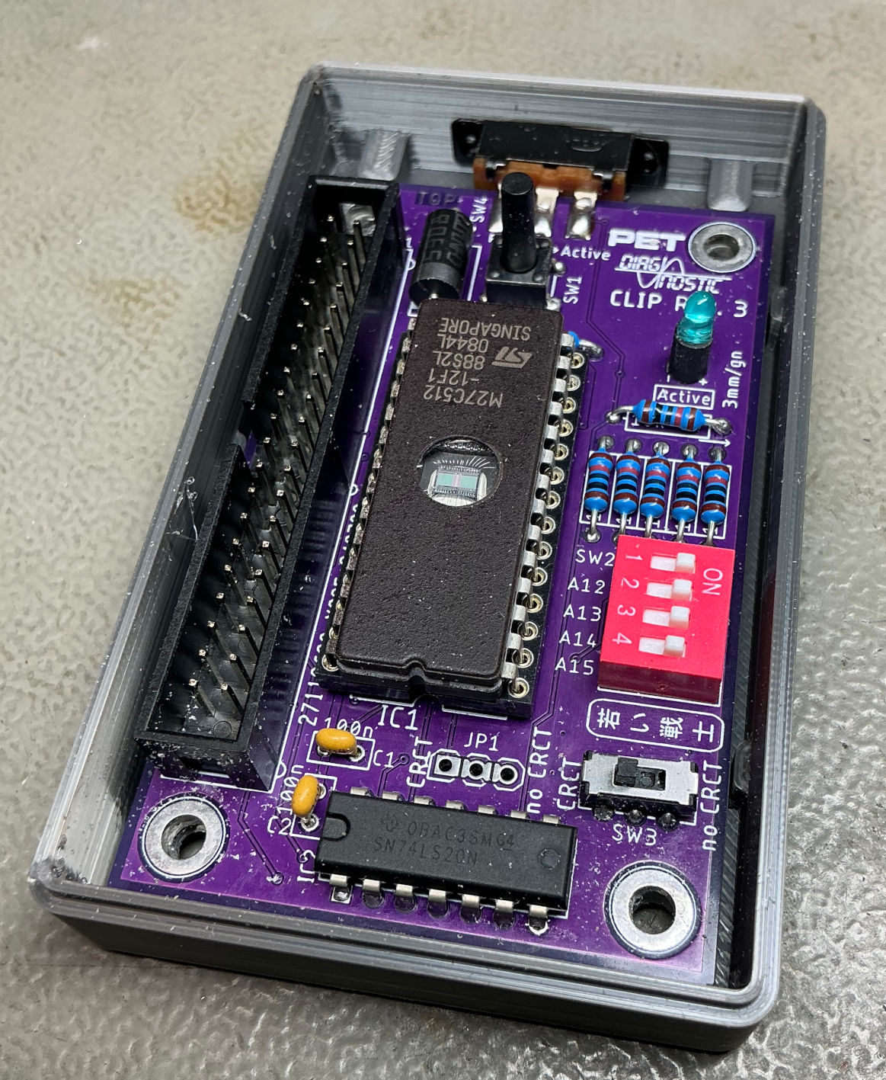
Figure 2: PCB v3 in bottom shell of the case

Ribbon Cable
The ribbon cable is used to connect the Diagnostic Clip (Box) to the 6502 Ribbon Cable Adapter. Since it directly connects to the address and data bus of the 6502, this ribbon cable should not be too long. 10cm -15cm are tested and acceptable.
The strain reliefs should be installed properly, because it is expected to be connected and disconnected several times.
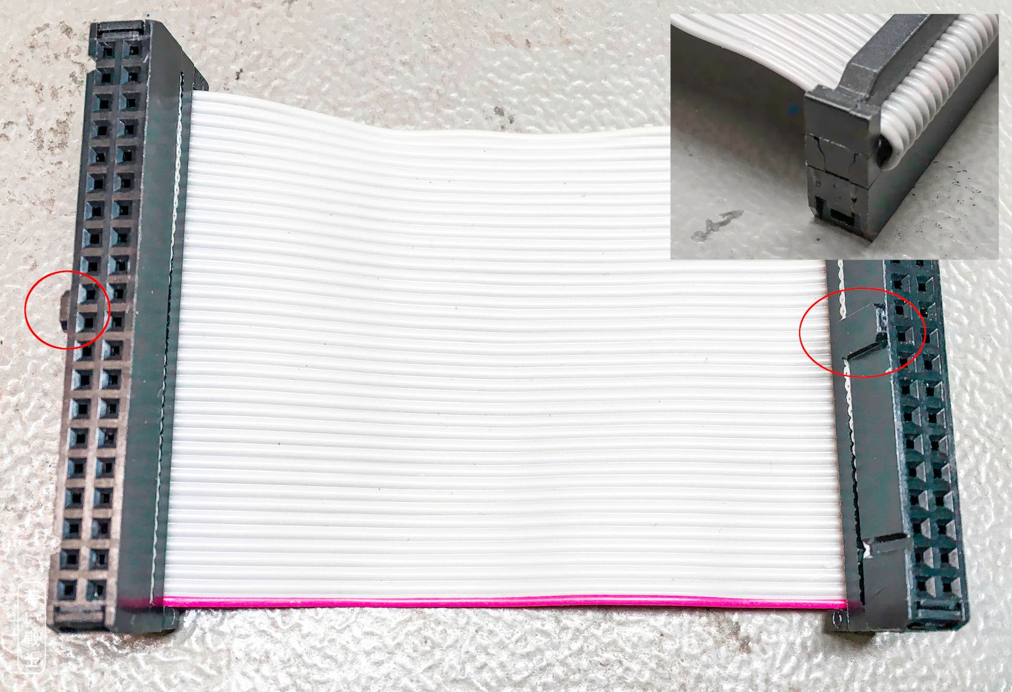
Figure 10: Ribbon cable
Building the ribbon cable is fairly simple. The ribbon cable itself is cut to length, both ends should be cut off perpendicular to the cable. The red wire marks pin one.
- Insert the cable into the IDC receptacle, be aware of the orientation (Figure 10, rec circles)
- Slightly squeeze the connector (to hold the ribbon cable)
- check, if the wires are placed exactly over the blades of the connector
- squeeze the connector with a vice (or a special IDC tool)
- bend the ribbon cable over the top of the connector and install the strain relief (Figure 10, top right).
Note: IDC means “Insulation-Displacement Connector”. When the crimping is carried out properly, the wires cold-weld to the blades, resulting in a gas tight connection. Refer to http://tech.guitarsite.de/cable_making.html#Ribbon%20Cables

Revision History

Rev. 0
- Prototype tested successfully with an 8032. Need for improvement.

Rev. 1
- DIP switch SW2 is 4 position now (no more “active”)
- Slide switch SW3 is new (CRTC ↔ non CRTC)
- Slide switch SW4 is new (active ↔ remove)

Rev. 2
- Support of the AND-gates on the ribbon cable adapter to set A13 and A14 low (for non CRTC mainboards).
- SW3 different circuit
- JP6 1x3 pin, different circuit
- Requires 6502 ribbon cable adapter Rev. 1 or later
- No more 3M DIP40 clip possible for non CRTC machines, since no grounding of A13 and A14

Rev. 3
- Active ↔Remove switch direct solder
- /NORAM is switched with the above switch (CBM8296 compatibility)
- New case Rev. 3 for the clip

